AUTH-014
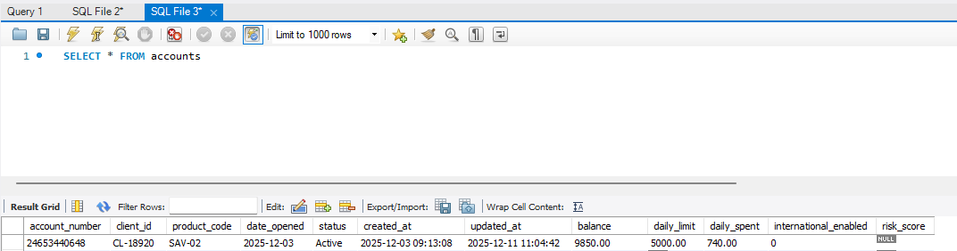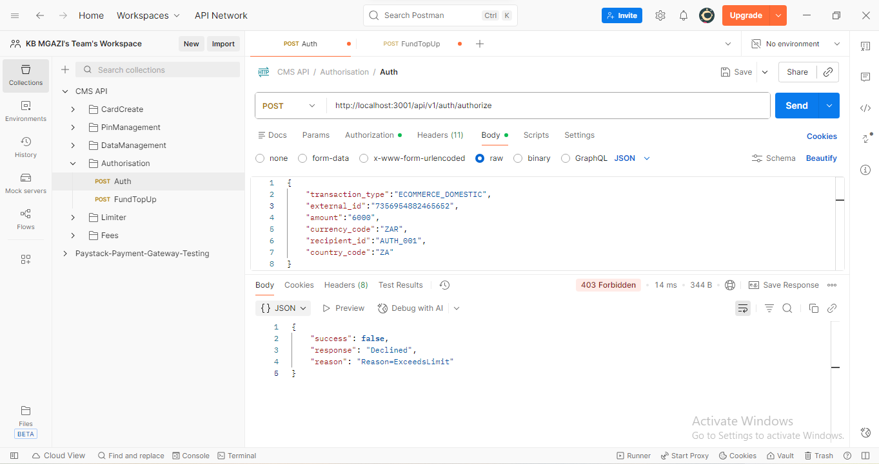
Request:
{
"transaction_type":"ECOMMERCE_DOMESTIC",
"external_id":"7356954882465652",
"amount":"6000",
"currency_code":"ZAR",
"recipient_id":"AUTH_001",
"country_code":"ZA"
}

Response:
{
"success": false,
"response": "Declined",
"reason": "Reason=ExceedsLimit"
}

